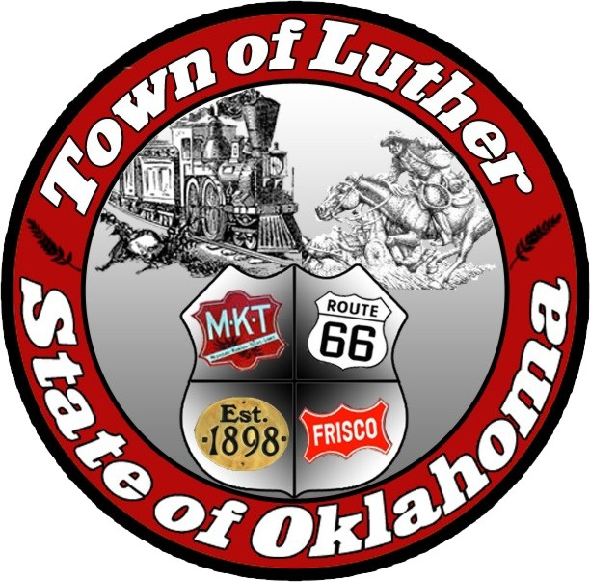
Town of Luther
Special Meeting - Town
Tuesday January 24th, 2017
Minutes

In accordance with the Open Meeting Act, Section 311, The Town of Luther, County of Oklahoma, 119 S. Main Street, hereby calls a Special Meeting of the Luther Public Works Authority Tuesday January 24th, 2017 at 6:30 p.m. at Luther Town Hall, 119 S. Main St., Luther, Oklahoma 73054

Meeting Called to Order
- Pledge of Allegiance
- Roll Call/// All in attendance.
- Declaration of Quorum…. Yes

Items before the Board

Item 1: Consideration, discussion and possible action regarding an additional room for 2 nights for the fire fighter training in February. To be paid out of the Fire Fighter account.-CL

Motion to approve, bringing the total, including the previous approved rooms to 4, not to exceed $800.00:CL… 2nd:BL… three yes votes…Henry & Taft abstain

Item 2: Consideration, discussion and possible action regarding a motel room for 3 nights for the police digital photography class in March. The class is free.- BL

Motion to approve and the camera becomes property of the town: BL …2nd:AM… 4 Yes votes… Henry votes No

Item 3: Consideration, discussion and possible action regarding having Town identification decals (Luther Police), added to the older unmarked police cars.-BL

Motion to approve, not to exceed $650.00:BL …2nd:AM… Unanimous yes vote/

Item 4: Adjourn

Motion to adjourn: BL …2nd:CL… Unanimous yes vote.

No new business can be brought up during a special meeting.

Kim Bourns, Town Clerk/Treasurer

*Agenda Posted January 23, 2017 at Luther Town Hall, on the website at

www.townoflutherok.com and on Facebook at The Town of Luther, at ____ pm.

