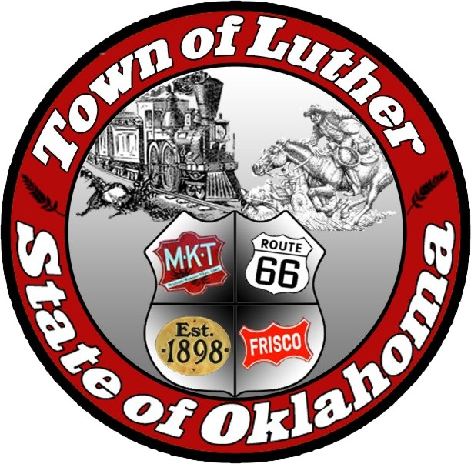
Luther Public Works Authority
Special Meeting
Tuesday February 7th, 2017

In accordance with the Open Meeting Act, Section 311, The Town of Luther, County of Oklahoma, 119 S. Main Street, hereby calls a Special Meeting of the Luther Public Works Authority Tuesday February 7th, 2017 at 1:00 p.m. at Luther Town Hall, 119 S. Main St., Luther, Oklahoma 73054

Meeting Called to Order
- Pledge of Allegiance
- Roll Call
- Declaration of Quorum

Items before the Board

Item 1: Consideration, discussion and possible action regarding hiring an individual for the position of Maintenance Man Number 2.

Item 2: Adjourn

No new business can be brought up during a special meeting.

Kim Bourns, Town Clerk/Treasurer

*Agenda Posted February 5, 2017 at Luther Town Hall, on the website at

www.townoflutherok.com and on Facebook at The Town of Luther, at ____ pm.

