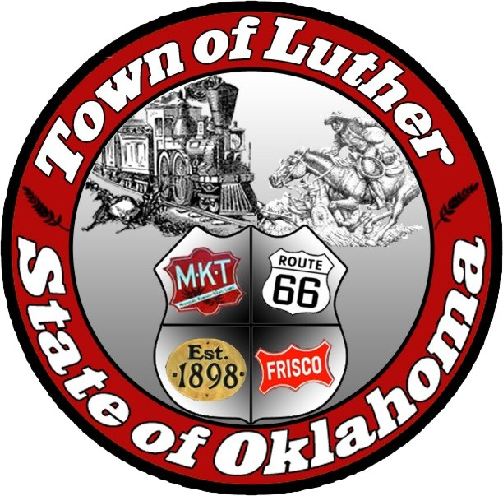
Luther Public Works Authority
Special Meeting
Thursday March 30th, 2017

In accordance with the Open Meeting Act, Section 311, The Town of Luther, County of Oklahoma, 119 S. Main Street, hereby calls a Special Meeting of the Luther Public Works Authority Thursday March 30th, 2017 at 7:00 p.m. at Luther Town Hall, 119 S. Main St., Luther, Oklahoma 73054

Meeting Called to Order
- Pledge of Allegiance
- Roll Call
- Declaration of Quorum

Items before the Board

Item 1: Consideration, discussion and possible action regarding the 2015/ 2016 Audit. - AM

Item 2: Consideration, discussion and possible action regarding the approval of the town bond for Luther’s Clerk/ Treasurer. – BL, AM

Item 3: Consideration, discussion and possible action regarding a public apology from the Town Board to Bryan Jasper of Oklahoma County. - BL

Item 4: Consideration, discussion and possible action regarding the proposed work on 7th street, approved on the March 14, 2017 regular board meeting. - AM

Item 5: Adjourn

No new business can be brought up during a special meeting.

Kim Bourns, Town Clerk/Treasurer

*Agenda Posted March 28, 2017 at Luther Town Hall, on the website at
www.townoflutherok.com and on Facebook at The Town of Luther, prior to 7:00 pm.

