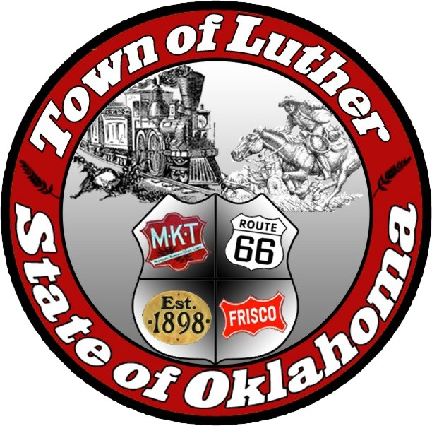
The Town of Luther
Special Meeting
Thursday April 27th, 2017

In accordance with the Open Meeting Act, Section 311, The Town of Luther, County of Oklahoma, 119 S. Main Street, hereby calls a Special Meeting of the Luther Board of Trustee’s on Thursday, April 27, 2017 at 7:00 p.m. at The Luther Community Building, 18120 E Hogback Rd, Luther, OK 73054

Meeting Called to Order
- Pledge of Allegiance
- Roll Call
- Declaration of Quorum

Items before the Board:

Item 1: Consideration, discussion, and possible action regarding an open discussion with the public pertaining to Town business, L.P.W.A. business and/ or other topics deemed relevant.

Item 2 : Adjourn.

No new business can be brought up during a special meeting.

Kim Bourns, Town Clerk/Treasurer

*Agenda Posted Tuesday April 25th, 2017 at Luther Town Hall, on the website at www.townoflutherok.com and on Facebook at The Town of Luther.

