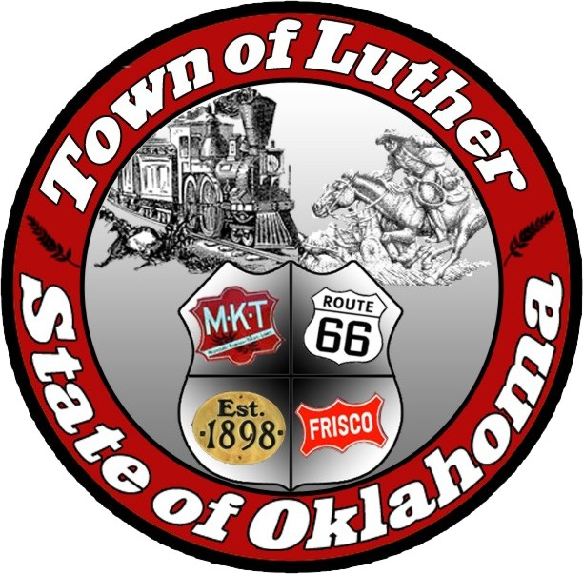
Luther Public Works Authority
Special Meeting
Tuesday May 2nd, 2017

In accordance with the Open Meeting Act, Section 311, The Town of Luther, County of Oklahoma, 119 S. Main Street, hereby calls a Special Meeting for the Luther Public Works Authority on Tuesday May 2nd, 2017 at 7:00 p.m. at The Luther Community Building, 18120 E Hogback Rd, Luther, OK 73054

Meeting Called to Order
- Pledge of Allegiance
- Roll Call
- Declaration of Quorum

Items before the Board:

Item 1: Consideration, discussion, and possible action regarding holding a workshop to set parameters for the budget for the L.P.W.A.

Item 2 : Adjourn.

No new business can be brought up during a special meeting.

Kim Bourns, Town Clerk/Treasurer

*Agenda Posted Friday April 28, 2017 at Luther Town Hall, on the website at www.townoflutherok.com and on Facebook at The Town of Luther.

