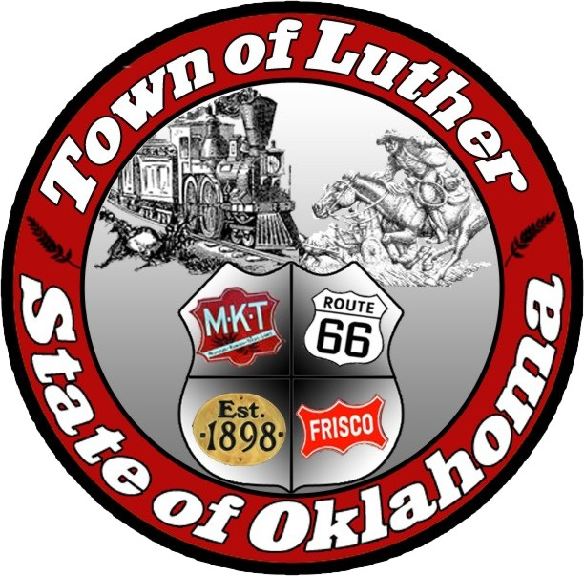
Board of Trustees for the Town of Luther
Luther Public Works Authority (L.P.W.A.)
Special Meeting Agenda
7:00 p.m. on June 6, 2017
Community Center at 18120 E. Hogback Rd., Luther OK 73054

In accordance with the Open Meeting Act, Section 311, The Town of Luther, County of Oklahoma, 119 S. Main Street, hereby calls a Special Meeting of the Board of Trustees for the Luther Public Works Authority, for the Town of Luther on Tuesday June 6, 2017 at 7:00: p.m.

Meeting Called to Order

Items before the Board:

Item 1: Trustee Comments

Trustee One
Trustee Two
Trustee Three
Trustee Four
No Agenda items

Trustee Five
Item 2: Consideration, discussion, and possible action regarding the passage of a resolution adopting the Luther Town/ LPWA Budget, prepared for fiscal year 2017, as required by law.

Item 3: Consideration and discussion regarding an open planning session with the public, pertaining to Town business, L.P.W.A. business and/ or other topics deemed relevant.

Item 4: Citizen Participation: Citizens may address the Board during open meetings on any item on the agenda prior to the board taking action on that particular item. On any matter not listed on the current agenda, citizens may address the Board under the agenda item, Citizen Participation. Citizens should fill out a Citizen Participation Request Form and give it to the Mayor. Citizen Participation is for information purposes only. The Board cannot discuss, act or make any decisions on matters presented under Citizen Participation. Citizens are requested to limit their comments to two minutes.

Item 5: Adjourn.

No new business can be brought up during a special meeting.

Kim Bourns, Town Clerk/Treasurer

*Agenda Posted Wednesday May 31, 2017 at Luther Town Hall, on the website at www.townoflutherok.com and on Facebook at The Town of Luther prior to 6:30 p.m.

