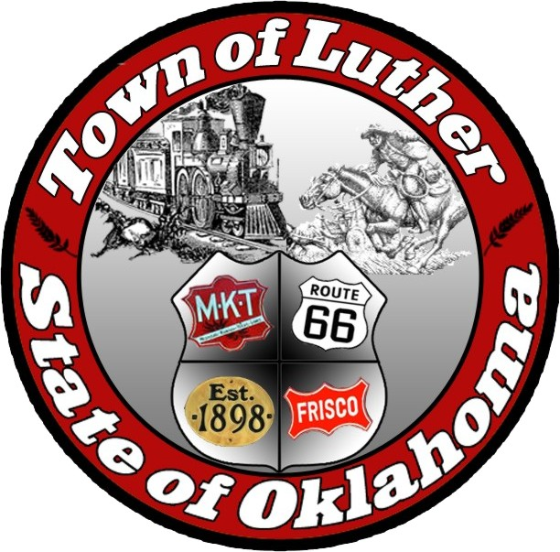
Luther Public Works Authority
Special Meeting
Thursday October 20th, 2016

In accordance with the Open Meeting Act, Section 311, The Town of Luther, County of Oklahoma, 119 S. Main Street, hereby calls a Special Meeting of the Luther Public Works Authority on Thursday October 20th, 2016 at 5:00 p.m. at Luther Town Hall, 119 S. Main St., Luther, Oklahoma 73054

Meeting Called to Order
- Pledge of Allegiance
- Roll Call
- Declaration of Quorum

Items before the Board:
Item 1: Consideration, discussion and possible action to create debt by borrowing $66,792.88 to purchase three vehicles at a price of $ 9,000.00 for the 2011 Chevy Tahoe and a price of $ 27,253.44 for the 2016 Ford with additional equipment in the amount of $ 2,839.44 and a price of $ 27,500.00 for the 2nd 2011 Chevy Tahoe and a $200.00 bank fee, for a total of $ 66,792.88 at 4,9% interest for a term of 66 months and to authorize the Mayor of Luther to sign the loan documents.

Motion: “I make a motion that the town of Luther, through the L.P.W.A, create debt through a First Bank & Trust loan, to purchase two 2011 Chevy Tahoes and a 2016 Ford with the additional equipment and a $200.00 bank fee, for a total of $66,792.88, at a interest rate of 4.9% for a period of 66 months and that the Mayor of Luther has the authorization to sign stated loan documents.”

Item 2: Adjourn

No new business can be brought up during a special meeting.

Kim Bourns, Town Clerk/Treasurer

*Agenda Posted October 19, 2016 at Luther Town Hall, on the website at

www.townoflutherok.com and on Facebook at The Town of Luther, at _____________.*

