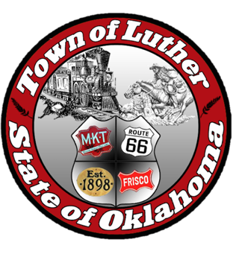
BOARD OF PARK COMMISSIONERS FOR THE TOWN OF LUTHER SPECIAL MEETING MINUTES

In accordance with the Open Meeting Act, Section 311, the Board of Parks Commission for the Town of Luther, County of Oklahoma, hereby call a Special Meeting of the Board of Park Commissioners of the Town of Luther, Monday, September 18, 2017 at 5:30 pm at the Luther Town Hall, 119 S. Main Street, Luther, OK 73054.

- Call to order.
- Roll Call. Absent: Andy McDaniels; Present: Jimmi Roach, Kasey Wood, Summer Shelton, and Michael Oliver
- Determination of a quorum. Yes

4. Open Discussion about the town Halloween events to take place on Saturday, Oct. 28th, 2017:

- Kasey Wood called the meeting to order at 5:34 pm.
- Pumpkin Passports: Participants that we know of so far: Luther Public School (Middle School Location), Chris Hill with the Service Center, Pam, First Bank and Trust, Police Dept., Fire Dept., Urban 66, possibly 116,
- Jimmie will handle flyers with Paxton and call to check printing prices (We will put Josh’s logo on flyers) Bring your own blanket or lawn chair should be added to flyer for the movie
- Jenni will get stamps for the passports
- Kasey will check with Josh Smith about equipment / setup
- Pumpkin Passports will be given to every attending business or organization to hand out to trick or treaters. The trick or treaters can start from anywhere on the pumpkin passport route.
- Trick or Treating hours are from 5-7pm. Movie in the park will begin between 7:00-7:15pm. Allowing a little bit of time for people to get settled in. We will encourage people to bring their blankets and lawn chairs for the movie.
- All businesses/organizations that wish to set up a trunk for the downtown "Trunk or Treat" will need to have their trunks set up by 4:30 pm.
- Deadline for those that wish to set up a trunk downtown will be Oct. 5th. We are inviting businesses that fall outside of the pumpkin passport route to set up if they wish.
- Downtown will be barricaded by 3:00pm
- Trick or Treating will end at WILDHORSE PARK at 7:00 pm. There, the Parks Commission will have a "trunk or treat" set up and will accept all pumpkin passports to be entered for a drawing for Sonic gift cards. Other free prizes will be given out.
- The movie in the park will be a double feature. The first movie will be a little kid friendly Halloween movie and the the second being geared for a slightly older audience. Suggestions were "It's a Great Pumpkin Charlie Brown" or "Curious George Halloween" for the first feature and "Hocus Pocus" or "Goosebumps" for the second feature.
- Flyers will be posted around town by Oct. 15th and flyers will go out to students in backpacks on the 25th or 26th.

5. Adjourn
Summer Shelton made a motion to adjourn at 6:47 pm and Kasey Wood seconded it.

