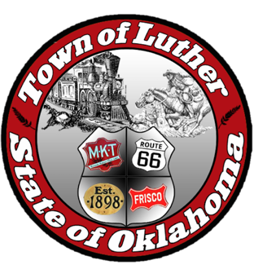
BOARD OF PARK COMMISSIONERS FOR THE TOWN OF LUTHER SPECIAL MEETING MINUTES

In accordance with the Open Meeting Act, Section 311, the Board of Parks Commission for the Town of Luther, County of Oklahoma, hereby call a Meeting of the Board of Park Commissioners of the Town of Luther, Thursday, September 7, 2017 at 6:30 pm at the Luther Town Hall, 119 S. Main Street, Luther, OK 7305

- Call to order.
- Roll Call. Absent: Andy McDaniels; Present: Jimmi Roach, Kasey Wood, Summer Shelton, and Michael Oliver
- Determination of a quorum. Yes

- Consideration, discussion, and possible action regarding “Movie in the Park” following presentation from Josh Smith from Opus Entertainment

Josh Smith donates his services, which include: projection screen and audio equipment. The town of Luther would be responsible for movie and rights to movie. More discussed in open discussion

- Consideration, discussion, and possible action regarding materials and grant information presented by Josh Trope from OKC- County Health Department (TSET)

Josh Trope suggested a plan to move forward with completing a community application for Certified Healthy. This year’s deadline is November 1, 2017, he suggested taking a year to complete all four-category breakdowns and apply by November 1, 2018. Commissioners must submit individual surveys of the parks by end of September. More Discussed in open discussion

6. Consideration, discussion and possible action regarding “Keep Oklahoma Beautiful” following presentation by Natalie Evans, Projects Coordinator

Natalie suggested that while becoming a Certified Healthy town, becoming an affiliate of “Keep Oklahoma Beautiful” would be the next step. Becoming an affiliate would give Luther the opportunity to apply for Roadside and Environmental beautification grants.

Requirements include:
- Complete a brief annual report
- Attend at least one KOB training session each year
- Submit $150 annual fee
- Participate annually in the Great American Cleanup and other KAB-KOB endorsed programs and projects
- Nominate a project/program in your community for an EEC award
- Use the name “Keep Luther Beautiful”

7. Open Discussion:

- The citizens of Luther will be provided a survey on the parks, either paper or electronic versions. Citizens should be seeing these surveys or survey links beginning in the months of November or December. Data of surveys should be analyzed in the months of January or February. All surveys are free to the town of Luther. Once survey is completed and data is analyzed, the design phase may begin.

- Town of Luther will be establishing a group of volunteer citizens to be “Friends of the Park.” This group will move forward with beginning paperwork for 501c 3 or 4 statuses, in order to begin fundraising efforts for the parks of Luther.

- Commission suggested a Halloween themed movie night, Saturday, October 28th to go along with Halloween celebrations in Luther. Movie services are still being considered. Theater in Chandler was mentioned as an alternative, for movie rights. If approved, movie night would begin at 7:00 pm with a possible double feature. The first being for small children, the second being a family friendly film.

- Other events were discussed for the spring season. A spring run of some type is a possibility.

- Discussion of responsibility / maintenance of ball fields near park in Luther.

8. Adjourn:

Mike Oliver made a motion to adjourn at 8:40. Summer Shelton seconded that motion.

