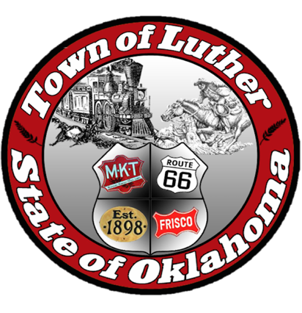
BOARD OF PARKS COMMISSION FOR THE TOWN OF LUTHER
6:30 p.m. September 7th, 2017
119 S Main St., Luther, OK 73054

- Call to order.
- Roll Call.
- Determination of a Quorum.
- Consideration, discussion, and possible action regarding “Movie in the Park” following presentation from Josh Smith from Opus Entertainment.
- Consideration, discussion, and possible action regarding materials and grant information presented by Josh Trope from OKC- County Health Department (TSET).
- Consideration, discussion, and possible action regarding Keep Oklahoma Beautiful following presentation by Executive Director of Keep Oklahoma Beautiful, Jeanette Nance.
- Open Discussion.
- Adjourn.

