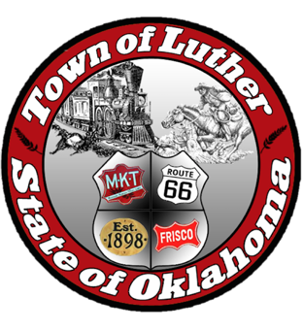
BOARD OF PARK COMMISSIONERS FOR THE TOWN OF LUTHER MEETING MINUTES

In accordance with the Open Meeting Act, Section 311, the Board of Parks Commission for the Town of Luther, County of Oklahoma, hereby call a Meeting of the Board of Park Commissioners of the Town of Luther, Thursday, October 5, 2017 at 6:30 pm at the Luther Town Hall, 119 S. Main Street, Luther, OK 73054

- Call to order. Kasey called meeting to order at 6:34 pm.
- Roll Call. Absent: Mike Oliver; Present: Jimmi Roach, Kasey Wood, Summer Shelton, and Andy McDaniels

3. Determination of a quorum. Yes
4. Review and approve meeting minutes from previous meetings. (August 3rd, September 7th, and September 18th of 2017)

Kasey moved to approve minutes from previous meetings and Andy seconded the motion. All present commissioners voted yes to approve minutes.

5. Consideration, discussion, and possible action regarding “Movie in the Park” on October 28, 2017, in Wildhorse Park. Confirm details for this event: movie start time, what title(s), pumpkin passport, drawings, etc.

Movie time was decided to begin between 7:05 and 7:15pm after drawing occurred. “Casper’s Halloween Special” was the title agreed upon for the movie in the park. All participating businesses so far discussed and listed for flyer: Luther Register, S&H Mercantile, Rustic Farm, First Bank and Trust, DJ’s, Boydston Funeral Home, Open Door Assembly of God, First Christian Church, Church of Christ Service Center, First Baptist Church, Urban 66, American Farmer’s and Rancher’s Insurance, 116 Farmstead Market, Alan Booher, Providence Realty, At Link, Luther Fire Department, and the Town of Luther.

Andy agreed to contact Chicken Shack and Dollar General, Mike was to follow up with Sonic on gift cards and participation in Trunk or Treat. Tuesday, Oct. 10th is the deadline for participants in order to complete flyer and post around town. Josh Trope with TSET can donate bouncy balls in lieu of candy at park if needed. Jimmi will get orange paper and have flyer printed and distribute to schools.
Summer made a motion to approve all plans for Trunk or Treat, Andy seconded that motion. The motion passed with a vote of yes by all present commissioners.

6. Consideration, discussion, and possible action regarding the grants we are working on with TSET Healthy Living.
All members will continue searching for grants. Andy suggested using Oklahoma Christian University’s grant finding library as a resource. All surveys will be turned in at the next meeting to Josh Trope and will be considered a “Town Hall” to gather information from the public on their ideas of how to better our parks. There will be three designated town hall meetings, where the town is encouraged to take part in discussion where we will gather email address to send the survey that TSET will provide. The three town hall discussions will be held at our regularly scheduled meetings in November, January, and February.

7. Open Discussion
No open discussion

8. Adjourn. Kasey made a motion to adjourn at 7:37pm and Jimmi seconded that motion. All present commissioners approved that motion.

