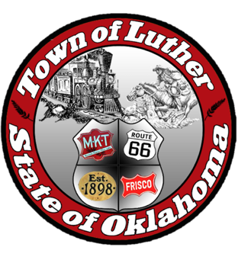
BOARD OF TRUSTEES FOR THE TOWN OF LUTHER
LUTHER PUBLIC WORKS AUTHORITY (LPWA)
SPECIAL MEETING AGENDA

In accordance with the Open Meeting Act, Section 311, the Town of Luther, County of Oklahoma, 119 S. Main Street, hereby call a Special Meeting of the Luther Public Works Authority, Thursday, January 25, 2018 at 7:00pm at the Luther Community Building, 18120 East Hogback Road, Luther, OK 73054.

- Call to order.
- Roll Call.
- Determination of a quorum.

Trustee Four (Jason Roach)

- Consideration, discussion and possible action to allow Lena Wright and Brian Proc to attend a OML class, Water Environmental Summit Workshop, at a cost of $85 each.

- Consideration, discussion and possible action to use the LPWA Meter ASSOC and Water Meter Association bank accounts for the $15,000 down payment of the new ultrasonic water meters.

- Adjourn.

________________________________________

Kim Bourns, Town Clerk/Treasurer

*Agenda posted at Luther Town Hall, on the website at www.townoflutherok.com and on Facebook at the Town of Luther, prior to 7:00 pm Tuesday, January 23, 2018.

