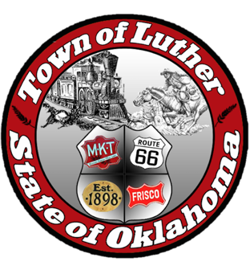
BOARD OF PARK COMMISSIONERS FOR THE TOWN OF LUTHER MEETING MINUTES

In accordance with the Open Meeting Act, Section 311, the Board of Parks Commission for the Town of Luther, County of Oklahoma, hereby call a Meeting of the Board of Park Commissioners of the Town of Luther, Thursday, January 4, 2018 at 6:30 pm at the Luther Town Hall, 119 S. Main Street, Luther, OK 73054

- Call to order. Kasey called meeting to order at 6:32 pm.
- Roll Call: Members Present: Kasey Wood, Summer Shelton, Andy McDaniels, and Ashlee Webster Absent: Michael Oliver

3. Determination of a quorum. Yes
4. Review and approve meeting minutes from November 2nd.

Andy moved to approve minutes from November 2nd and Kasey seconded the motion. All commissioners voted yes to approve minutes.

5. Hear from Josh Trope concerning Certified Healthy and the Park Assessments for Wildhorse Park.

Josh handed out pamphlets on all grant information. October 31, 2018 is the deadline for applying for Certified Healthy. We will move forward with Kaboom grant and look into the Lowes toolbox grant. Consider asking Bank First & Trust to match our fundraising goal for future grants.

6. Consideration, discussion and possible action regarding the next steps with Certified Healthy and the next Town Hall dates.

Our master plan is due by May. Kasey made a motion to set town hall meetings for February 1st and March 1st at 7:00. Summer seconded that motion. All members voted in favor.

7. Consideration, discussion and possible action on the Oklahoma Freewheel event on June 12th and 13th of 2018

Look into Luther Public Schools Booster Clubs to participate. Ask Dawn Shelton to be part of the welcoming committee. Andy will contact Jim Ross to provide entertainment on the evening of June 12th. Look into the gymnasium for indoor sleeping accommodations. AtLink and TSET will possibly provide drinks for cyclists. Set special meeting for January 11th to discuss this event in further detail.

8. Consideration, discussion and possible action regarding our events for July 4th, 2018.

Ideas of a picnic in the park with fireworks and food vendors discussed, no motions made. Contact fire chief regarding fireworks.

9. Consideration, discussion and possible action on Keep Oklahoma Beautiful grants to apply for in 2018.

The $150 fee for application was paid, so we can now move forward with application process. Look into tree grants with ODOT.

10. Open Discussion
Easter event was discussed but no motions were made.

11. Adjourn. Kasey made a motion to adjourn at 8:17pm and Andy seconded that motion. All commissioners approved that motion.

