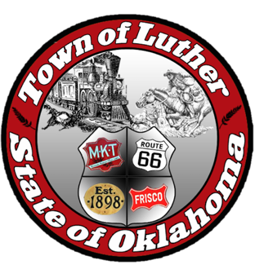
BOARD OF PARK COMMISSIONERS FOR THE TOWN OF LUTHER MEETING MINUTES

In accordance with the Open Meeting Act, Section 311, the Board of Parks Commission for the Town of Luther, County of Oklahoma, hereby call a Meeting of the Board of Park Commissioners of the Town of Luther, Thursday, February 8, 2018 at 6:30 pm at the Luther Town Hall, 119 S. Main Street, Luther, OK 73054

- Call to order. Kasey called meeting to order at 6:34 pm.
- Roll Call: Members Present: Kasey Wood, Summer Shelton, and Andy McDaniels Absent: Ashlee Webster

3. Determination of a quorum. Yes

4. Hear from Josh Trope concerning Certified Healthy and the Park Assessments for Wildhorse Park.

Parks Commission will move forward applying for the Lowe’s and Kaboom grant. Jenni may have a donor for our portion of the grant. There is also a new grant that we will apply for that is due end of February

5. Consideration, discussion, and possible action regarding the next steps with Certified Healthy.

We agreed to divvy up meetings with Josh for Certified Healthy, will schedule dates through email.

6. Consideration, discussion and possible action on Oklahoma Freewheel event on June 12th and 13th of 2018.

- TSET will sponsor water and ice for freewheel event. Jenni will need to submit a sponsorship request for $300 plus an additional $100 for ice. Josh also mentioned a coworker may be able to help sponsor through their department (Health Department). Andy spoke with At Link and they will sponsor something as well (possibly tents from Mary Ann’s) one for food, one for entertainment.

- We need to find out from Trevor what the theme of the day will be.

- We will look into getting Tres Suenos Winery and the liquor store involve. Jenni will also ask The Boundary to come to campsite area. Booster clubs will be allowed to provide food during the day, and we will set up a time schedule for this.

- An emergency/ first aid station, massage therapists and the Tide Laundry truck/ Porta Kleen were all mentioned as possibilities.

- We will prepare for 500.

- The idea of putting business cards with coupons on the back of the cyclists’ maps was mentioned.

- Jenni will speak with Steve about placing tents on the corner and we will place a series of signs down the cycling route. We will ask Titanic’s about hay bale painted like a bicycle wheel.

- Andy will provide tractor hay rides.

- We will contact Josh Smith about having a DJ and or foam party that day.

- 116, Sonic and Josephine’s were mentioned as breakfast spots in addition to booster clubs.

7. Consideration, discussion and possible action regarding adding attendance requirements to our by-laws.

Discussion tabled until all members are present.

8. Open Discussion
- We will set a date for another meeting to discuss dates for The Great American Cleanup. It launches March 20th.
- Andy will contact Oklahoma Wildlife Confederation to discuss sprays for the parks that will not be harmful to bees or butterflies.

9. Adjourn. Kasey made a motion to adjourn at 7:55 pm and Andy seconded that motion. All commissioners approved that motion.

