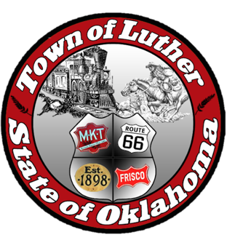
BOARD OF TRUSTEES FOR THE
TOWN OF LUTHER
LPWA REGULAR MEETING AGENDA

In accordance with the Open Meeting Act, Section 311, The Town of Luther, County of Oklahoma, 119 S. Main Street, hereby calls a Luther Public Works Authority Meeting of the Luther Board of Trustees, Tuesday April 10, 2018 at 7:00 p.m. at The Luther Community Building, 18120 East Hogback Road, Luther, OK 73054.

- Call to order.
- Roll call.
- Determination of a quorum.
- Approval of the minutes for the following meeting(s), March 13 LPWA & March 22 Special LPWA as prepared by the Town Clerk/Treasurer and subject to additions or corrections by the Board of Trustees.
- Report of the Treasurer.
- Review of claims.
- Trustee Comments.

Trustee Four (Jason Roach)

- New Business: In accordance with the Open Meeting Act, Title 25 O.S. 311.A.9, new business is defined as any matter not known about or which could not have been reasonably foreseen prior to the time of posting the agenda.

- Citizen participation: Citizens may address the Board during open meetings on any matter on the agenda prior to the Board taking action on the matter. On any item not on the current agenda, citizens may address the Board under the agenda item Citizen Participation. Citizens should fill out a Citizen’s Participation Request form and give it to the Mayor. Citizen Participation is for information purposes only, and the Board cannot discuss, act or make any decisions on matters presented under Citizens Participation. Citizens are requested to limit their comments to two minutes.

- Adjourn.

_______________________________________________
Kim Bourns, Town Clerk/Treasurer

*Agenda posted Monday, April 9, 2018 at Luther Town Hall, on the website at www.townoflutherok.com and on Facebook at the Town of Luther, prior to 7:00 p.m.

