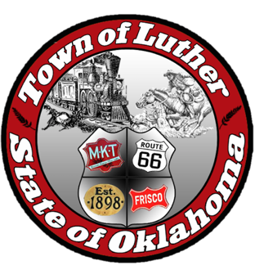
BOARD OF TRUSTEES FOR THE TOWN OF LUTHER
SPECIAL LPWA MEETING AGENDA

In accordance with the Open Meeting Act, Section 311, The Town of Luther, County of Oklahoma, 119 S. Main Street, hereby calls a Special Meeting of the Luther Board of Trustees LPWA, Thursday, May 31, 2018 at 6:30 p.m. at Town Hall, 119 S. Main Street, Luther, OK 73054.

- Call to order.
- Roll Call
- Determination of a quorum

Trustee Two (Lea Ann Jackson)

- Consideration, discussion and possible action regarding the 2018-19 Budget for LPWA.

- Consideration, discussion and possible action to publish approved, LPWA budget for an upcoming public hearing.

- Consideration, discussion and possible action to move funds from the operating account to the Rainy Day account.

- Consideration, discussion and possible action to establish policy regarding the use of funds in the Rainy Day account.

- Adjourn.

________________________________
Kim Bourns, Town Clerk/Treasurer

*Agenda Posted Tuesday, May 29, 2018 at Luther Town Hall, on the website at www.townoflutherok.com and on Facebook at The Town of Luther, prior to 6:30 pm.

