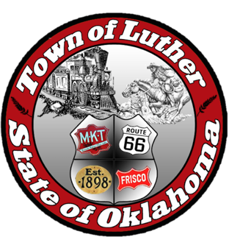
BOARD OF TRUSTEES FOR THE TOWN OF LUTHER
SPECIAL LPWA MEETING AGENDA

In accordance with the Open Meeting Act, Section 311, The Town of Luther, County of Oklahoma, 119 S. Main Street, hereby calls a Special LPWA Meeting of the Luther Board of Trustees, Tuesday, June 5th, 2018 at 6:30 p.m. at The Luther Community Building, 18120 East Hogback Road, Luther, OK 73054.

- Call to order.
- Roll Call
- Determination of a quorum.
- Approval of the minutes for the following meetings, May 8th Regular LPWA, May 24th & 31st Special LPWA, as prepared by the Town Clerk/Treasurer and subject to additions or corrections by the Board of Trustees.
- Report of the Treasurer.
- Review of claims including payroll.
- Trustee Comments.

Trustee Two (Lea Ann Jackson)

- Consideration, discussion and possible action to commit to meeting requirements of the OMAG Recognition program which can result in reduction of insurance premiums for LPWA.

- Consideration, discussion and possible action to move $7,907.23 from operating account to restricted CD for meter deposits.

- Citizen participation: Citizens may address the Board during open meetings on any matter on the agenda prior to the Board taking action on the matter. On any item not on the current agenda, citizens may address the Board under the agenda item Citizen Participation. Citizens should fill out a Citizen’s Participation Request form and give it to the Mayor. Citizen Participation is for information purposes only, and the Board cannot discuss, act or make any decisions on matters presented under Citizens Participation. Citizens are requested to limit their comments to two minutes.

- Adjourn.

_______________________________________________
Kim Bourns, Town Clerk/Treasurer

*Agenda Posted Friday June 1, 2018 at Luther Town Hall, on the website at www.townoflutherok.com and on Facebook at The Town of Luther, prior to 6:30 pm.

