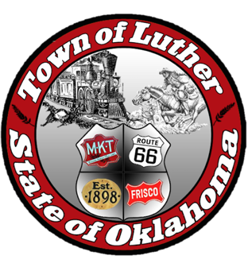
BOARD OF TRUSTEES FOR THE TOWN OF LUTHER
SPECIAL TOWN MEETING AGENDA

In accordance with the Open Meeting Act, Section 311, The Town of Luther, County of Oklahoma, 119 S. Main Street, hereby calls a Special Town Meeting of the Luther Board of Trustees, Thursday, June 7th, 2018 at 5:30 p.m. at Town Hall, 119 S. Main St., Luther, OK 73054.

- Call to order.
- Roll Call
- Determination of a quorum.
- Board members will hear from Freese and Nichols engineers, concerning the Town Master Plan.

Trustee Five (Jenni White)

- Consideration, discussion and possible action regarding approval of the Town of Luther Master Plan.

- Citizen participation: Citizens may address the Board during this open meeting on the current agenda. Citizens are requested to limit their comments to two minutes.

- Adjourn.

_______________________________________________
Kim Bourns, Town Clerk/Treasurer

*Agenda Posted Monday June 4, 2018 at Luther Town Hall, on the website at www.townoflutherok.com and on Facebook at The Town of Luther, prior to 5:30 pm.

