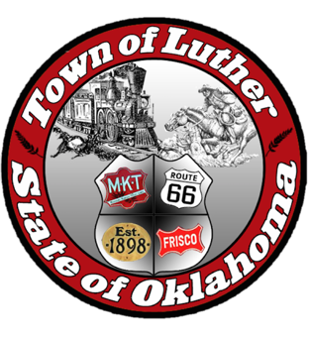
BOARD OF TRUSTEES FOR THE TOWN OF LUTHER
SPECIAL LPWA MEETING AGENDA - PUBLIC HEARING & MEETING

In accordance with the Open Meeting Act, Section 311, The Town of Luther, County of Oklahoma, 119 S. Main Street, hereby calls a Special Meeting of the Luther Board of Trustees for the LPWA, Thursday, June 14, 2018 at 6:30 p.m. at Town Hall, 119 s. Main St., Luther, OK 73054.

- Call to order.
- Roll Call
- Determination of a quorum.
- Trustee Comments
- Presentation and open discussion with the citizens of Luther pertaining to the 2018 - 2019 budget for the operation of the Town of Luther.

Trustee One (Paxton Cavin)

Trustee Two (Lea Ann Jackson)

- Consideration, discussion and possible action to adopt the budget resolution for 2018 - 2019.

Trustee Three (Trandy Langston)

Trustee Four (Jason Roach)

Trustee Five (Jenni White)

- Consideration, discussion and possible action to adopt a new letterhead for the Town of Luther.

- Adjourn.

_______________________________________________
Kim Bourns, Town Clerk/Treasurer

*Agenda Posted Tuesday, June 12, 2018 at Luther Town Hall, on the website at www.townoflutherok.com and on Facebook at The Town of Luther, prior to 6:30 pm.

