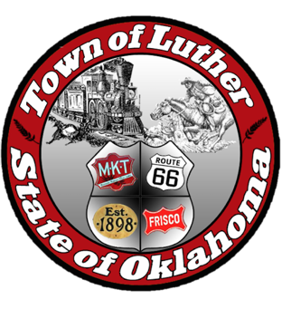
BOARD OF TRUSTEES FOR THE TOWN OF LUTHER
LUTHER PUBLIC WORKS AUTHORITY (LPWA)
SPECIAL MEETING AGENDA

MINUTES

In accordance with the Open Meeting Act, Section 311, the Town of Luther, County of Oklahoma, 119 S. Main Street, hereby call a Special Meeting of the Luther Public Works Authority, Thursday, March 22, 2018 at 6:30pm at the Luther Community Building, 18120 East Hogback Road, Luther, OK 73054.

- Call to order.
- Roll Call… All Present
- Determination of a quorum… Yes

Trustee Four (Jason Roach)

- Consideration, discussion and possible action to hire high school-aged students to assist with the mowing of Town property including the cemetery at a starting hourly wage equaling minimum wage.
Motion to approve as written: J. Roach… 2nd: J. White… Unanimous Yes vote.

- Citizen participation: Citizens may address the Board during open meetings on any matter on the agenda prior to the Board taking action on the matter. On any item not on the current agenda, citizens may address the Board under the agenda item Citizen Participation. Citizens should fill out a Citizen’s Participation Request form and give it to the Mayor. Citizen Participation is for information purposes only, and the Board cannot discuss, act or make any decisions on matters presented under Citizens Participation. Citizens are requested to limit their comments to two minutes.
No Action

- Adjourn.
Motion to adjourn: J. White… 2nd: J. Roach… Unanimous Yes vote.

____transcribed 03/23/2018 by____

Kim Bourns, Town Clerk/Treasurer

*Agenda posted at Luther Town Hall, on the website at www.townoflutherok.com and on Facebook at the Town of Luther, prior to 6:30 pm Tuesday, March 20, 2018.

