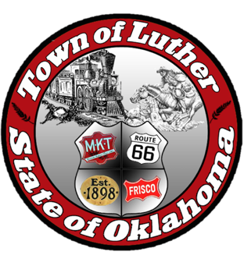
BOARD OF TRUSTEES FOR THE TOWN OF LUTHER
SPECIAL LPWA MEETING AGENDA - PUBLIC HEARING & MEETING

In accordance with the Open Meeting Act, Section 311, The Town of Luther, County of Oklahoma, 119 S. Main Street, hereby calls a Special Meeting of the Luther Board of Trustees for the LPWA, Thursday, June 14, 2018 at 6:30 p.m. at Town Hall, 119 s. Main St., Luther, OK 73054.

- Call to order.
- Roll Call… P. Cavin & T. Langston absent.
- Determination of a quorum… Yes
- Trustee Comments
- Presentation and open discussion with the citizens of Luther pertaining to the 2018 - 2019 budget for the operation of the Town of Luther.
No Action

Trustee One (Paxton Cavin)

Trustee Two (Lea Ann Jackson)

- Consideration, discussion and possible action to adopt the budget resolution for 2018 - 2019.
Motion to approve as written: L. Jackson… 2nd: J. Roach… three yes votes.

Trustee Three (Trandy Langston)

Trustee Four (Jason Roach)

Trustee Five (Jenni White)

- Consideration, discussion and possible action to adopt a new letterhead for the Town of Luther.
Motion to approve with a LPWA format: J. White… 2nd: J. Roach… three yes votes.

- Adjourn.
Motion to adjourn: J. Roach … 2nd: L. Jackson … three yes votes.

____transcribed 06/15/2018 by____
Kim Bourns, Town Clerk/Treasurer

*Agenda Posted Tuesday, June 12, 2018 at Luther Town Hall, on the website at www.townoflutherok.com and on Facebook at The Town of Luther, prior to 6:30 pm.

