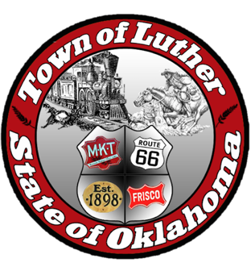
BOARD OF TRUSTEES FOR THE TOWN OF LUTHER
LPWA SPECIAL MEETING AGENDA

In accordance with the Open Meeting Act, Section 311, The Town of Luther, County of Oklahoma, 119 S. Main Street, hereby calls a Special Meeting of the Luther Board of Trustees for LPWA for Tuesday September 4th, 2018 at 6:30 p.m. at Town Hall, 119 S. Main Street, Luther, OK 73054.

- Call to order.
- Roll Call… P. Cavin absent.
- Determination of a quorum… Yes

Trustee Five (Jenni White)

- Consideration, discussion and possible action to address the water and sewer rates. Discussion to include a presentation from Millie Vance.
No Action

- Adjourn
Motion to adjourn: L. Jackson… 2nd: J. Roach… Four Yes votes.

___transcribed 09/07/2018 by____
Kim Bourns, Town Clerk/Treasurer

*Agenda Posted Friday, August 30th , 2018 at Luther Town Hall, on the website at www.townoflutherok.com and on Facebook at The Town of Luther, prior to 6:30 pm.

