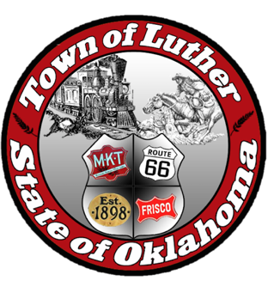
BOARD OF PARK COMMISSIONERS FOR THE TOWN OF LUTHER MEETING MINUTES

In accordance with the Open Meeting Act, Section 311, the Board of Parks Commission for the Town of Luther, County of Oklahoma, hereby call a Meeting of the Board of Park Commissioners of the Town of Luther, Thursday, March 1, 2018 at 6:30 pm at the Luther Town Hall, 119 S. Main Street, Luther, OK 73054

- Call to order. Kasey called meeting to order at 6:35 pm.
- Roll Call: Members Present: Kasey Wood, Summer Shelton, and Ashlee Webster Absent: Andy McDaniels and Chris Ivitch

3. Determination of a quorum. Yes

4. Approve minutes for January and February regular meetings:

Kasey made a motion to approve minutes; Ashlee seconded that motion.

5. Update on grant information and progress:

Josh will send out updates and assign roles for each portion of grant process. For the Kaboom grant, three categories:
1. Timeline (8-12wks to assess/pick playground equipment)
2. Grant writer to be chosen
3. Attend Events at Luther Parks and document with pictures

Kaboom grant closes October 31, 2018 and grant will be submitted January 1, 2019.

Lowes grant will be submitted 2019.

6. Consideration, discussion and possible action regarding the next steps with Certified Healthy, Kaboom and Lowe’s Grants.

No action

7. Consideration, discussion and possible action regarding adding attendance requirements to our by-laws.

Kasey made a motion to approve ordinance that any commissioner absent for two regularly scheduled meetings and two special meetings during a twelve month period will be subject to a vote by the board as to whether they will continue on the board. Motion was seconded by Summer. All present members voted yes.

8. Consideration, discussion and possible action on the Oklahoma Freewheel event on June 12th and 13th of 2018:

Ashlee will contact High School clubs and organizations. Summer will contact Middle School clubs and organizations. Kasey and Jenni will contact businesses. Information meeting for businesses is set for March 20th at 6:30pm. School and other organizations set for March 27th at 6:30pm. Band and Cheer will be welcome to perform at the welcome rally on June 12th. Kasey will contact DJ, Josh Smith. Jenni will look into rental of tent. Eddy from Chicken Shack confirmed he will have a food truck at site with breakfast burritos.

9. Open Discussion:

No action

10. Adjourn:

Kasey made a motion to adjourn at 8:32pm; Summer seconded that motion.

