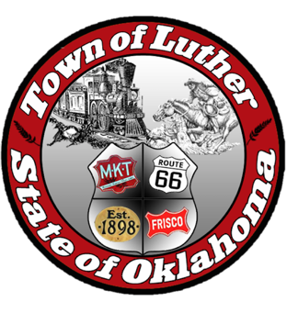
BOARD OF PARKS COMMISSIONERS
FOR THE TOWN OF LUTHER
Parks Commission Regular Meeting
Thursday, March 4, 2020
6:30 pm
Luther Town Hall
108 S. Main St.
Luther, OK 73054

AGENDA

- Call meeting to order.
- Roll call.
- Determine a quorum.
- Consideration, discussion, possible action made on 2021 Christmas Event.
- Consideration, discussion, and possible action on presentation of the OU Concept Plan for WildHorse Park.
- Consideration, discussion, and possible action on fundraising events for 2021.
- Open discussion.

Agenda posted March 3, 2021, before 6:30 pm

