Board of Parks Commissioners for the Town of Luther
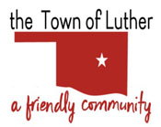
108 S Main, PO Box 56
Luther, OK 73054
Phone: 405-277-3833
Fax: 405-277-9965

BOARD OF PARKS COMMISSIONERS FOR THE TOWN OF LUTHER
REGULAR MEETING AGENDA
Thursday, June 3, 2021
6:30 PM, Town Hall, 108 S Main St, Luther, OK 73054

- Call to Order.
- Roll Call.
- Determination of a quorum.
- Discussion and possible action regarding Wildhorse Park.
- Consideration, discussion and possible action on 2021 budget items for submission to Town Board.
- Adjourn.

Posted 6/2/2021 before 6:30 p.m.

________________________________
Scherrie Pidcock, Acting Town Clerk

