Spring is in Full Swing and that means warmer weather and more Outdoor Activities. You still need to be aware and Stay Safe riding a Bike, Scooter, Skateboard, or Roller Skates. That means using your head and when I say use your head, I mean using your Common Sense.
- Make sure your Bike is the Right fit for you and your feet can reach the pedals and the ground when you are stopped.
- Wear Your Helmet right and Wear it tight. Adjust the Straps so they are snug under your chin. (Even the Pros cyclists wear their Helmets. You might think you won’t Crash until you do)
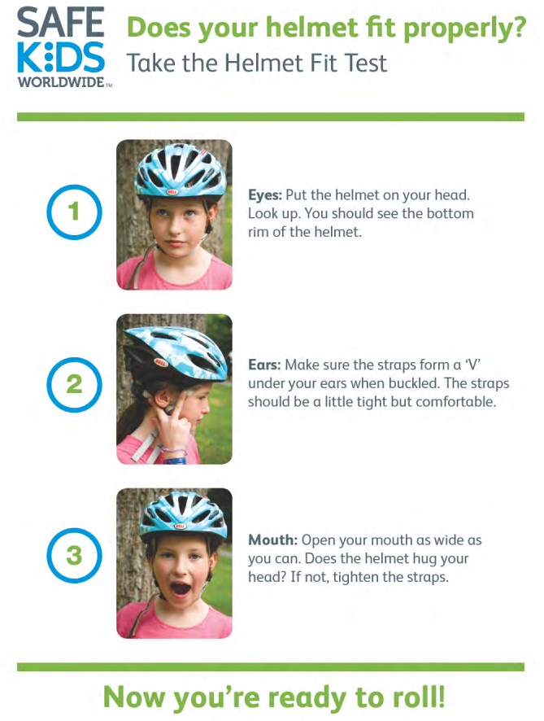
- Wear clothes that Are BRIGHT and DON’T Ride at Night or early Sunrise without Reflectors and LIGHTS. If they can’t see you, you can’t see them.
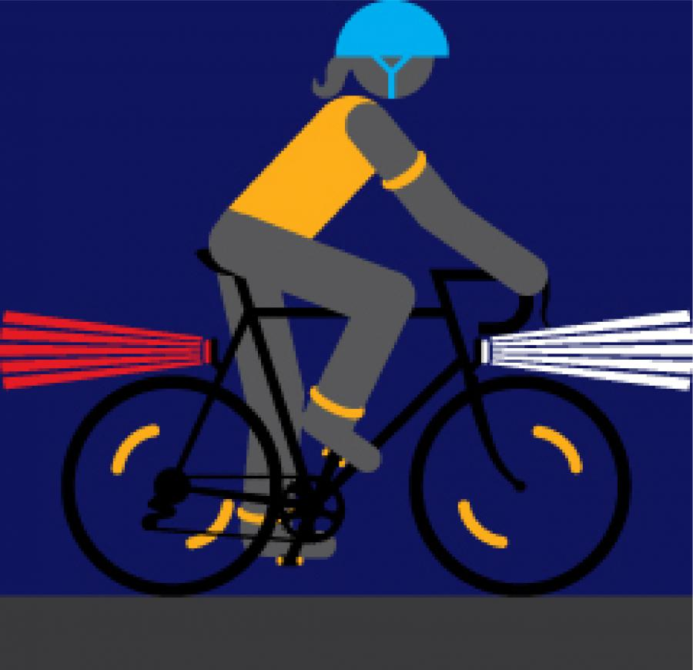
- Show you Care by STAYING AWARE of your Surroundings. STAY ALERT, DON’T get Hurt!
- When Crossing an Intersection, look both ways twice and make sure the Drivers see you via Eye Contact.

